Assignment 6 -SSIS

Hands-On Lab 9: Build ETL Pipeline
Scenario
Load customer data from:
CSV → Staging Table → DWH Table
Steps
1 Load CSV
2 Clean data
3 Load to warehouse

Step 1: Load CSV into Staging Table
- Create staging table in SQL Server:
CREATE TABLE Customer_Staging (
CustomerID INT NULL,
CustomerName VARCHAR(100) NULL,
Email VARCHAR(100) NULL,
Age INT NULL,
City VARCHAR(50) NULL
);
- In SSIS / Visual Studio:
  - Create Integration Services Project
  - Add Data Flow Task → Load CSV to Staging
- Inside Data Flow:
  - Add Flat File Source → select customer_data.csv
  - Check columns, delimiter, and first row has column names
- Add OLE DB Destination → connect to Customer_Staging
  - Map columns from CSV → staging table

Step 2: Clean Data using Derived Column
- Drag Derived Column between Flat File Source → OLE DB Destination
- Derived Column configuration:
  - Derived Column Name = same as column you’re replacing (Age / Email)
  - Action = Replace Column
  - Data type for Age = DT_I4 (integer)
  - Data type for Email = DT_WSTR with length same as table column

Step 3: Load Cleaned Data into DWH Table
- Create DWH Table:
CREATE TABLE Customer_DWH (
CustomerID INT,
CustomerName VARCHAR(100),
Email VARCHAR(100),
Age INT,
City VARCHAR(50)
);
- Add second Data Flow Task → Load Cleaned Data to DWH
- Source: Customer_Staging
- Add Derived Column (same rules as above) to ensure Age / Email are cleaned
- Destination: Customer_DWH → map all columns
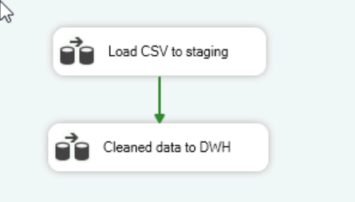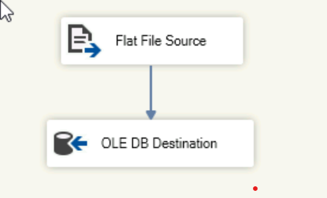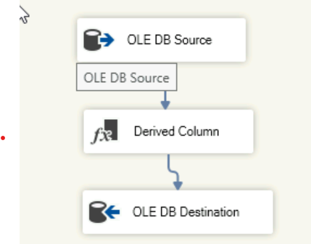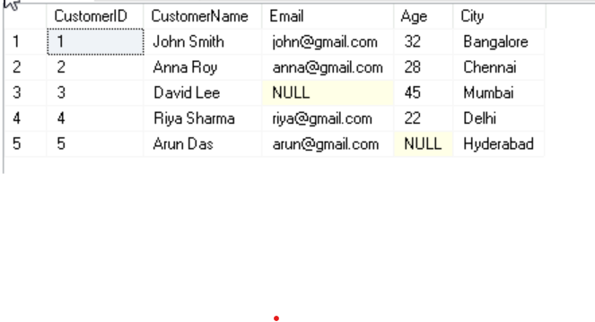

Step 4: Execute Package
- Press F5 to run the package
- Check Execution Results / Progress tab
- Verify Customer_DWH table:
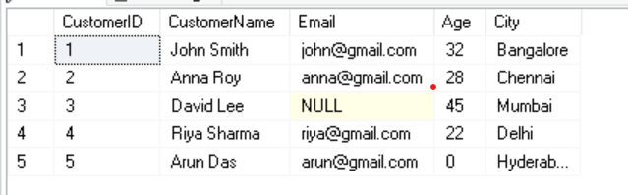

Hands-On Lab 10: Database Migration
Source
Legacy Customer DB

Destination
New Data Warehouse

Use:
- OLE DB Source
- Data Flow
- OLE DB Destination

Step 1: Prepare Source Table
- Create the legacy customer table and add sample data.
CREATE TABLE Customers (
CustomerID INT PRIMARY KEY,
CustomerName VARCHAR(100),
Email VARCHAR(100) NULL,
Age INT NULL,
City VARCHAR(50) NULL
);

Step 2: Prepare Destination Table
- Create the data warehouse table where data will be migrated.
CREATE TABLE Customer_DWH (
CustomerID INT PRIMARY KEY,
CustomerName VARCHAR(100),
Email VARCHAR(100) NULL,
Age INT NULL,
City VARCHAR(50) NULL
);

Step 3: Create SSIS Project
- Open Visual Studio / SSDT
- Create a new Integration Services Project
- Name it
Step 4: Add Data Flow Task
- Go to Control Flow tab
- Drag Data Flow Task into the workspace
- Double-click to open Data Flow tab
Step 5: Configure OLE DB Source
- Drag OLE DB Source into Data Flow
- Click New → create connection to your database
  - Use Windows Authentication if possible
  - Select Customer table
- In OLE DB Source Editor:
  - Data access mode: Table or view
  - Name of table or view: Customers
  - Click Preview to check data
Step 6: Configure OLE DB Destination
- Drag OLE DB Destination into Data Flow
- Connect OLE DB Source → OLE DB Destination (green arrow)
- Select Customer_DWH as the destination table
- Click Mappings → map all columns
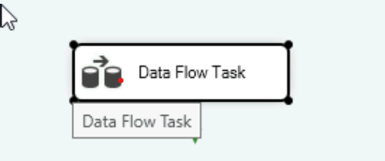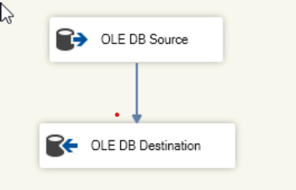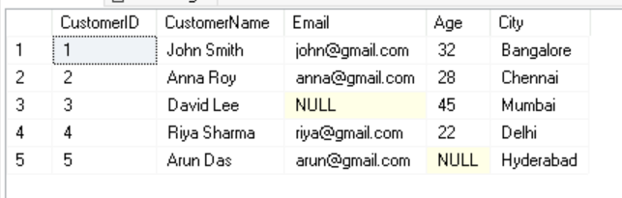

Step 7: Execute Package
- Press F5 to run the package
- Check Execution Results for success
